Solid Waste Management PS5210
3.0 credits

Instructor: Haralambos V. Vasiliadis, Ph.D., P.E., DEE, D.WRE, CIH

Course Overview

The course covers management aspects of solid waste:

- Course overview

The main topics covered in this course include generation of solid waste in municipal, commercial and industrial sectors with proper identification and characterization of various waste streams involved with emphasis on waste prevention in terms of mass, volume and toxicity at the source, along the processing phase and at the disposal facility, as well as waste minimization by waste reuse and recycling in major commercial and industrial sectors (such as paper, glass, plastics, metals, wood, tire, electronics and construction/demolition wastes) including analysis of state-of-art technologies.

In addition, various collection and transport methods are covered along with all typical disposal methods, including incineration, sanitary landfill, composting, recovery and reutilization. Economic evaluations of factors affecting selection of disposal methods and its impact of reuse/recycling along with all applicable local, state and national legislative trends and regulatory requirements.

Furthermore, examples of public and private reuse and recycling programs in New York City are covered.

Finally, sustainability-related topics are covered, including, but not limited, to:

    - Impact of reuse and recycling of wastes on CO₂ emissions, urban sustainability and global warming.
    - Impact on waste quantities and characteristics due to urbanization, climate change, (national) wealth, life-style, consumption patterns and cultural behavior.
    - Innovative eco-centered waste management methods and state-of-the art technologies used to process materials for reuse and recycling

- The course is an elective offering in the MS in Sustainability Management program. The course will be opened, space-permitting, to cross-registrants from other fields and/or Columbia University programs including the broader School of Professional Studies, School of International and Public Affairs and Graduate School of Arts and Sciences.

- Larger programmatic goals: This course is one of the Physical Dimensions of Sustainability Management courses of the Sustainability Management curriculum which prepares students for careers in the dynamic and rapidly changing field of sustainability. The curriculum emphasizes i) the physical dimensions of sustainability (e.g., solid waste, greenhouse gas emissions, and environmental infrastructure), general and financial management, economics, quantitative analysis, and policy so that students can thrive in the job market, and ii) the practical skills and core knowledge that practitioners need to face for both the known challenges of the present, as well as the unforeseen challenges of the future.

In addition, the physical dimensions requirement teaches students about the connections between environmental inputs and outputs and their effects on the natural environment. The emphasis in this requirement will be on students understanding the environmental impacts from organizational activities, receiving the required knowledge and learning certain tools that will allow them to advance in their professional careers and become leaders in their fields and to help public and private organizations and governments address environmental impacts and risks, pollution control, and remediation to achieve sustainability.

​Learning Objectives

By the end of this course, all students should be able to:

- Demonstrate a broad understanding of the solid waste issue, perceive it as a critical sustainability issue, be able to implement an effective reusing and recycling plan in the municipal, commercial, and industrial sectors, and draw logical conclusions and, more importantly, to make the right decisions through critical thinking with the use of optimization methods about solid waste management. [L1]
- Examine real-life applications where each person can have a noticeable contribution in addressing the solid waste issue by considering/adopting primarily the “5R” approach/policy: Reducing, Reusing, Recycling (reprocessing and recovering), Rejecting solid waste and Reacting to solid waste (as needed). [L2]
- Analyze real-world case studies and compare the means and methods used to optimize the management of solid waste, and more particularly of recyclable wastes. [L3]
- Assess the environmental life cycle of materials. [L4]
- Compare technologies used to process materials for reuse and recycling in major sectors. [L5]
- Evaluate the environmental impact of solid waste applications. [L6]
- Relate and rate the specialized reuse and recycling programs in New York City and other cities in the US. [L7]

Readings

The required core references and recommended ones are listed below. You may access all references via:

https://1drv.ms/u/s!AmKYUAPSdn9GjfgR031CtLzxjrXG-A?e=uXgWct

Core Texts:

1. Sustainable Solid Waste Management: A Systems Engineering Approach, N-B Chang and A. Pires, IEEE/J. Wiley, Inc., 2015, ISBN: 9781-118-45691-0
2. Sustainable Solid Waste Management, J. W. C. Wong, R. Y. Surampalli, A, Selvam, R. D. Tyagi, ASCE, 2016
3. Handbook of Solid Waste Management, G. Tchobanoglous and F. Kreith, McGraw-Hill, Inc, 2nd Edition, 2002, ISBN: 0-07-135623-1
4. Disposal and Management of Solid Waste – Pathogens and Diseases, E. Epstein, Editor, CRC Press, 2015

Recommended Readings:

- Introduction to Environmental Engineering, M. L. Davis and D. A. Cornwell, McGraw-Hill, 5th Edition, ISBN: 978-0-07-340114-0 – Ch 2: Materials Balances, Ch. 3: Risk Assessment, Ch. 11: Solid Waste Management, Ch. 12: Hazardous Waste Management
- Life-Cycle Analysis of Integrated Waste Management, O. Parkes et al, Elsevier, 2015 (article)
- Manual on Municipal Solid Waste Management, India, 2000
- Municipal Solid Waste Management Manual, Part I, India, 2015
- Solid Waste Disposal Facility Criteria – Technical Manual, EPA, 1993
- Municipal Waste Management, United Kingdom, 2013
- Solid Waste Landfill – Design Manual, Washington State, 1987
- Waste Reduction Manual, Washington State, 1994

Columbia University Information Technology

Columbia University Information Technology (CUIT) provides Columbia University students, faculty, and staff with central computing and communications services. Students, faculty, and staff may access University-provided discounted software downloads (https://columbiait.onthehub.com/).

Columbia University Library

Columbia University’s extensive library system ranks in the top five academic libraries in the nation, with many of its services and resources available online: https://library.columbia.edu/.

SPS Academic Resources

The Office of Student Affairs provides students with academic counseling and support services such as online tutoring and career coaching: http://sps.columbia.edu/student-life-and-alumni-relations/academic-resources.

Course Requirements (Assignments)

Each student should write an essay for one of the following four (4) case studies and for one of the following five (5) research topics. Other case-studies and/or reading assignments could be proposed.

Case Studies:

- Is America drowning in garbage? Now robots are being on duty to help solve the recycling crisis. The U.S. is facing a recycling crisis that is burying cities and towns in tens of millions of tons of garbage a day. The situation is dire for many cities and towns as recycling costs skyrocket, so more garbage is ending up in landfills and incinerators. Companies and municipalities are turning to AI-assisted robots to help sort garbage in recycling plants. Will this AI-assisted approach help in the positive direction? [www.cnbc.com – “America is drowning in garbage…”]

- Is Japan’s recycling system the most complicated in the world? It sure feels like it sometimes. For example, household waste must of course be separated into burnable and non-burnable, but after that there’s a dizzying array of recycling categories to break your non-burnable waste into. Since Japan is a relatively small country without masses of land to use for burying waste, the vast majority of waste used to be incinerated. However, due to increasing ecological awareness, new legislation attempts to minimize the amount of waste being burnt and to promote recycling. Furthermore, the problem lies not only in the array of recycling categories, but also in the apparent overlap between them: the grey areas. What is the reasoning behind this? [soranews24.com – “Recycling in Japan…”]

- An African city is turning a mountain of trash into energy. Could this turn one of Africa's most challenging social problems, the management of waste, into a source of new wealth? [weforum.org – “This African city is turning a mountain of trash into energy”]

- Compare the option of allowing residents to enter into individual contracts with haulers on a per household basis (i.e., unregulated solid waste collection and transportation) against a citywide pickup program with reference to a) cost and impact of transportation, b) lack of official waste quantity generation estimates, c) control of disposal and overall ultimate management methods and practices, etc. [https://www.minnpost.com/metro/2019/09/st-pauls-epic-fight-over-trash-collection-explained/]

Research Topics:

- Solid waste treatment and disposal: effects on public health and environmental safety, Hamer G., 2003 - https://www.ncbi.nlm.nih.gov/pubmed/14623044

- Waste Mismanagement in Developing Countries: A Review of Global Issues, Navarro Ferronato and Vincenzo Torretta, 2019 - https://www.ncbi.nlm.nih.gov/pmc/articles/PMC6466021/

- Solid Waste Management in Developing Countries: Status, Perspectives and Capacity Building, L.F. Diaz, CalRecovery, Inc., Concord, California USA, Intergovernmental Preparatory Meeting for CSD-19, United Nations Headquarters, New York, USA -- March 3, 2011 - https://sustainabledevelopment.un.org/content/documents/ldiaz.pdf

- A Systems Approach to Community Engaged Solid Waste Management, Rachael Marshall, 2013 - https://ec.europa.eu/echo/files/evaluation/watsan2005/annex_files/WEDC/es/ES07CD.pdf

- RCRA’s Critical Mission & the Path Forward, 2015 - https://www.epa.gov/sites/production/files/2015-09/documents/rcras_critical_mission_and_the_path_forward.pdf

The Case Study report should be in the form of a newspaper article (about 1,000 words) where the student has to present it in an understandable, fully explained and interesting way. On the day of the mid-term exam, each student will make a PowerPoint (or similar) presentation and submit a report for evaluation. A minimum of 3 sources/references is required for this task. The status of the Case Study report will be evaluated prior to the final presentation (see syllabus for the date of evaluation).

Student should use at least 3 references to complete the Research Case study (about 2,500 words) which will be presented on the day of the final exam. The status of the Research Study report will be evaluated prior to the final presentation (see syllabus for the date of evaluation).

Electronic copies of the essays and presentations (both in editable and pdf format) should be submitted prior to the presentation (mid-term and final, respectively). Periodic meetings to evaluate the status and potential of each essay are highly recommended.

Class review:

During the first three (3) minutes of each class, one or two students will present a synopsis of the material covered in the previous class. Students may receive up to five (5) bonus points for their class review presentation.

Creative question:

Students will be asked at the end of each class to express (through ZOOM chat) a creative question related to the material covered in class. One of the creative questions will be selected within 24 hours and students will be asked to write a paragraph (about 250 words) answering the question. All answers should be submitted electronically 24 hours before the next class for evaluation. Upon evaluation, all answers will be posted on Canvas and will be accessible to all students.

Evaluation/Grading

The final grade will be calculated based on the following scale and assignment percentages:

Grade | Percentage |  | Assignment | % Weight
A+ | 98–100 % |  | Participation | 10
A | 93–97.9 % |  | Class review | 10
A- | 90–92.9 % |  | Creative question and answer | 10
B+ | 87–89.9 % |  | Case Study assignment progress | 10
B | 83–86.9 % |  | Case Study assignment final presentation and report | 20
B- | 80–82.9 % |  | Research assignment progress | 10
C+ | 77–79.9 % |  | Research assignment final presentation and report | 30
C | 73–76.9 %
C- | 70–72.9 %
D | 60–69.9 %
F | 59.9% and below

Course Policies

Participation and Attendance

You are expected to complete all assigned readings, attend all class sessions, and engage with others in online discussions. Your participation will require that you answer questions, defend your point of view, and challenge the point of view of others. If you need to miss a class for any reason, please discuss the absence with me in advance.

Late work

Work that is not submitted on the due date noted in the course syllabus without advance notice and permission from the instructor will be graded down 1/3 of a grade for every day it is late (e.g., from a B+ to a B).

Citation & Submission

All written assignments must use citation format, cite sources, and be submitted to the course website (not via email).

School Policies [Include all school/university policies as written below.]

Copyright Policy

Please note—Due to copyright restrictions, online access to this material is limited to instructors and students currently registered for this course. Please be advised that by clicking the link to the electronic materials in this course, you have read and accept the following:

The copyright law of the United States (Title 17, United States Code) governs the making of photocopies or other reproductions of copyrighted materials. Under certain conditions specified in the law, libraries and archives are authorized to furnish a photocopy or other reproduction. One of these specified conditions is that the photocopy or reproduction is not to be "used for any purpose other than private study, scholarship, or research." If a user makes a request for, or later uses, a photocopy or reproduction for purposes in excess of "fair use," that user may be liable for copyright infringement.

Academic Integrity

Columbia University expects its students to act with honesty and propriety at all times and to respect the rights of others. It is fundamental University policy that academic dishonesty in any guise or personal conduct of any sort that disrupts the life of the University or denigrates or endangers members of the University community is unacceptable and will be dealt with severely. It is essential to the academic integrity and vitality of this community that individuals do their own work and properly acknowledge the circumstances, ideas, sources, and assistance upon which that work is based. Academic honesty in class assignments and exams is expected of all students at all times.

SPS holds each member of its community responsible for understanding and abiding by the SPS Academic Integrity and

Community Standards posted at http://sps.columbia.edu/student-life-and-alumni-relations/academic-integrity-and-community-standards. You are required to read these standards within the first few days of class. Ignorance of the School's policy concerning academic dishonesty shall not be a defense in any disciplinary proceedings.

Accessibility

Columbia is committed to providing equal access to qualified students with documented disabilities. A student’s disability status and reasonable accommodations are individually determined based upon disability documentation and related information gathered through the intake process. For more information regarding this service, please visit the University's Health Services website: https://health.columbia.edu/services/ods/support.

Class Recordings

All or portions of the class may be recorded at the discretion of the Instructor to support your learning. At any point, the Instructor has the right to discontinue the recording if it is deemed to be obstructive to the learning process.
If the recording is posted, it is considered confidential and it is not acceptable to share the recording outside the purview of the faculty member and registered class.

Course Schedule/Course Calendar

No | Date | Topic (T), learning objectives [L#], reading assignment (R), pertaining questions (Q) and notes (N)
1 | 2021.01.14 | T: Integrated solid waste management (ISWM), sources and quantities [L1, L2]  R: Chapter 1 of Textbook No. 1, Chapter 1 of Textbook No. 2  Q: What is the distinction between materials and wastes? Are materials reusable, recovered, recyclable, etc. and wastes discarded, abandoned, burned/incinerated, etc.? Is ISWM a comprehensive and effective program to protect human health and the environment? What are the major activities involved in ISWM and what is required to make this program comprehensive and effective?
2 | 2021.01.21 | T: Federal, State and City/Local legislation, (i.e., RCRA, CERCLA, TSCA, etc.) [L1]  R: Chapter 4 of Textbook No. 1  Q: Is the SW-related legislation really complicated? Is full compliance with all applicable rules and regulations feasible? Are there grey areas? Could legislative evaluation and oversight improve the legislative decision-making process by providing information about the performance of agencies and programs? Could updating the solid waste laws solve problems related to financing, enforcement, public awareness, definitions, roles/responsibilities, etc.?
3 | 2021.01.28 | T: Types and characteristics of waste streams [L1]  R: Chapter 2.1 – 2.4 of Textbook No. 1, Chapter 2 of Textbook No. 2, Reference 1  Q: How critical is the lack of accurate and reliable data and analytics in all phases of solid waste management?
4 | 2021.02.04 | T: Management of RCRA-regulated hazardous and universal wastes, TSCA-regulated materials (PCBs, Asbestos, etc.), special wastes and materials [such as, batteries, used oil, scrap tires, construction and demolition debris (C&D), computer (e-waste) and other electronic solid wastes (e-waste), household hazardous wastes, biosolids, etc.], as well as healthcare/medical and radioactive wastes, etc. [L1]  R: Chapter 2.5 of Textbook No. 1, Chapters (Introduction and Conclusions) 12, 13, 14, 15 and 16 of Textbook No. 2, Chapters 10 (entire chapter) and 11 (description and characteristics only of various Special Wastes) of Textbook No. 3, and HV Notes - [for healthcare/medical waste: Textbook No. 4 and for radioactive waste: 10 CFR Part 20 and HV Notes]  Q: Why are there so many toxic household products (biocides, bleaches, paints, etc., including prescription and OTC drugs) and how do they expect us to manage them properly?  N: Status evaluation of Case Study report
5 | 2021.02.11 | T: Collection and transportation of solid waste [L1]  R: Chapters (selected topics) 15 and 19 of Textbook No. 1, Chapter 3 of Textbook No. 2, and Chapter 7 of Textbook No. 3  Q: Could system analysis methods and optimization techniques in conjunction with real-time GPS systems improve the overall performance?
6 | 2021.02.18 | T: Source quantity and toxicity reduction (including reuse) [L5]  R: Chapter 4 of Textbook No. 2, Chapter 6 of Textbook No. 3, Reference 8  Q: How can I reduce my trash? Are there any practical and effective ways? Is there a promising outcome by doing this?
7 | 2021.02.25 | T: Recycling and markets and products for recycled materials [L1, L2]  R: Chapter 17 of Textbook No. 1, Chapter 5 of Textbook No. 2, Chapters 8 and 9 of Textbook No. 3  Q: Is public awareness of the need to recycle high? Does the public experience “grey areas”? For example, is an empty pizza box considered recycled paper? Or is it burnable? Paper packages? “Other”? And if a bottle is made of a different type of plastic to the standard PET, is still a “pet bottle”, or is it just “plastic”? Why is it hard to recycle given that many municipalities complain that residents fail to participate? Is recycling really effective? What are we doing with the recycled material? How can we balance the demand and supply of recycled materials? What is the right method to recycle? Are we doing the right thing?
-- | 2021.03.04 | Spring Break [Monday, March 1-Friday, March 5]
8 | 2021.03.11 | Mid-term exam – Presentation of Case Study assignment
9 | 2021.03.18 | T: Composting [L1, L2]  R: Chapters 8 and 9 of Textbook No. 2, Chapters 12 (12.1, 12.5 and 12.7) and 15 (15.1 – 15.3) of Textbook No. 3, Reference 1  Q: Why composting sounds such a promising management method but it is not becoming popular?
10 | 2021.03.25 | T: Incineration: waste-to-energy combustion and emission control [L1, L2]  R: Chapter 17 of Textbook No. 1, Chapter 7 of Textbook No. 2, Chapter 13 of Textbook No. 3, Reference 1  Q: Why do European countries have an extensive incineration program compared to US?
11 | 2021.04.01 | T: Land disposal: Landfilling [L1, L2]  R: Chapter 18, 19 and 20 of Textbook No. 2, Chapter 14 of Textbook No. 3, Reference 1 and 7  Q: Is there a real issue with landfills? Are we running out of space? Are the issues related to toxins, leachates (i.ee., groundwater contamination), greenhouse gases (methane gas formation and mitigation), disease vector hazards, etc. from landfills really critical? What are the economic and environmental issues of landfills? Is “not in my backyard (NIMBY)” a real politico-social issue and is this opposition play a significant role in stakeholders decision making? Is it an unsustainable form of waste management? What are the 7 federal and the 6 performance-based criteria for municipal solid waste landfills?
12 | 2021.04.08 | T: Social and economic concerns, Risk assessment and management, and Life-cycle analysis (LCA) [L1, L2, L6]  R: Chapters 3, 5 and 10 of Textbook No. 1, Chapter 22 of Textbook No. 2, Chapter 16 of Textbook No. 3, References 1 and 2  Q: What types of improvement are required at each phase of a LCA, which stands as the pre-eminent tool for estimating environmental effects caused by products and processes from ‘cradle to grave’ and despite its popularity and codification by organizations, to address individual problems, to bridge existing gaps, to overcome limitations, to address current challenges (such as allocation, uncertainty, biodiversity, etc.) as well as to provide a unified treatment in order to achieve a robust, sustainable and credible use of LCA?  N: Status evaluation of Research Study report
13 | 2021.04.15 | T: Innovative approaches to solid waste management [L3, L7]  R: Chapters 6, 7 and 8 of Textbook No. 1, HV Notes  Q: NYC Department of Sanitation’s “Zero Waste Initiative: NYC’s ambitious goal to send zero waste to landfills by 2030, knowing that about a third of New Yorkers' waste can be recycled through the City’s curbside recycling program, another third can be recovered through the City’s organics programs, and another 10% (textiles, electronic waste, harmful household products, and plastic bags) can be diverted through donations and take-back programs. Instead of sending trash to a far-away landfill or incinerator, pledge to reduce, reuse, and recycle!” Is such an initiative ambitious? Is it realistic and feasible?  T: A holistic approach for sustainable material management (SMM) [L1, L2, L6]  R: Chapters 13, 14, 16 and 18 of Textbook No. 1, HV Notes  Q: Is EPA transitioning from focusing on integrated solid waste management (ISWM) to focusing on sustainable materials management (SMM), which refers to the use and reuse of materials across their entire life cycle in order to conserve resources, reduce waste, and minimize the environmental impacts of materials? Could this transitioning achieve solid waste management is a sustainable manner? What does sustainability mean in this case? Sustain what?  N: Last day of classes: Thursday, April 15
14 | 2021.04.22 | Reading and Exam Days [Friday, April 16-Friday, April 23]  Final exam - Presentation of Research Study assignment

School Policies and Expectations:

- Academic Integrity – Full compliance with the Code of Academic and Professional Conduct is required. Any violations will be reported to the Associate Dean for Students Affairs. The Code of Academic and Professional Conduct can be viewed online:

http://sps.columbia.edu/student-life-and-alumni-relations/academic-integrity-and-community-standards

- Accessibility Statement – Columbia University is committed to providing equal access to qualified students with documented disabilities. For more information regarding this service, please visit the University’s Health Services website:

http://health.columbia.edu/disability-services

Personal statement

I value an inclusive and equitable environment for all our students and I hope to foster a sense of community in this class and consider it a place where individuals of all backgrounds, beliefs, ethnicities, national origins, gender identities, sexual orientations, religious and political affiliations, and abilities will be treated with respect. It is my intent that all students’ learning needs be addressed both in and out of class, and that the diversity that students bring to this class be viewed as a resource, strength and benefit. If this standard is not being upheld, please feel free to speak with me.

Background

A solid waste is any discarded material (abandoned, recycled, considered inherently waste-like, or military munition). As per NYS DEC, solid waste is any garbage, refuse, sludge, etc. and other discarded materials including solid, semi-solid, liquid, or contained gaseous material, resulting from municipal, commercial, industrial, mining and agricultural activities and operations. Other types of wastes are liquid wastes (from point and non-point sources), air emissions (from mobile sources or stationary sources, and other types of wastes, such as healthcare/medical and radioactive wastes.

Other types of wastes are liquid wastes (from point and non-point sources) and air emissions (from mobile sources or stationary sources. A waste classification is shown below.

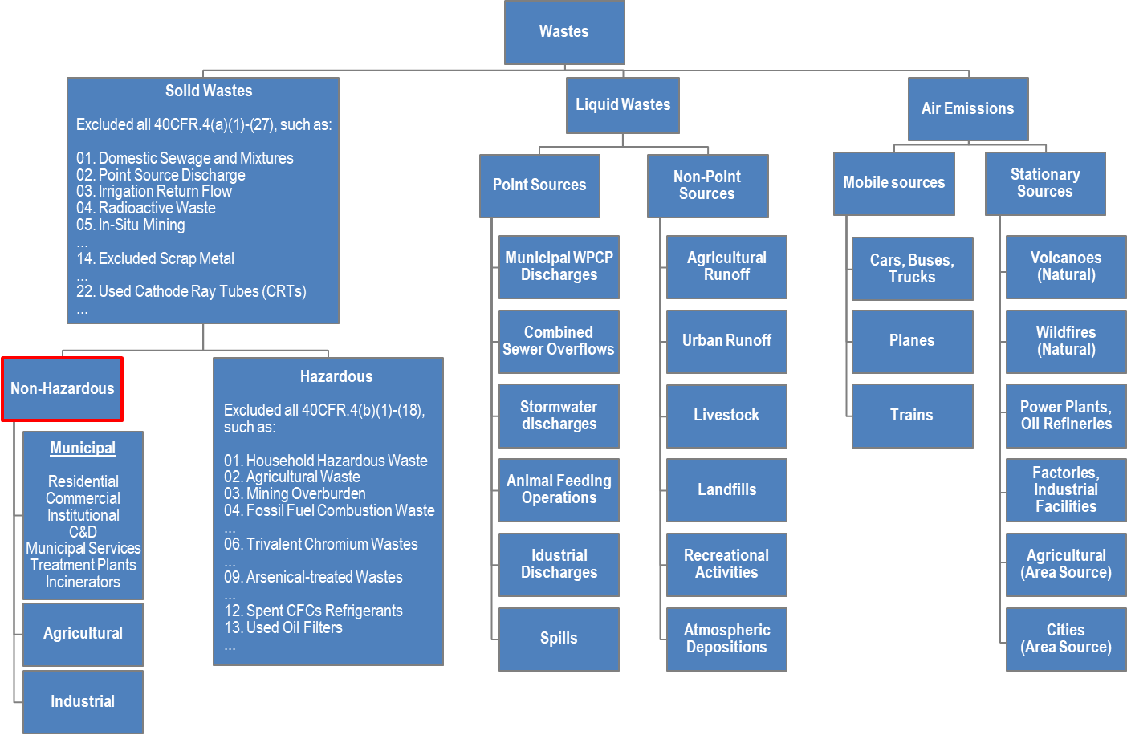

In US, on average, we recover (through recycling and composting) 1.51 pounds (34.3%) of our individual waste generation of 4.40 pounds per person per day. In 2013, Americans generated about 254 million tons of trash and recycled and composted about 87 million tons of this material. Improperly managed solid waste poses a risk to human health and the environment. It may result in safety hazards from fires or explosions, and increases greenhouse gas (GHG, such as water vapor, carbon dioxide, methane, nitrous oxide, and ozone) emissions which contribute to climate change.

Solid waste management (SWM) has been an integral part of every human society. As per US-EPA, SWM is a challenge because waste generation increases with population expansion and economic development. Improperly managed solid waste poses a risk to human health and the environment. Uncontrolled dumping and improper waste handling cause a variety of problems, including contaminating water, attacking insects and rodents, and increasing flooding due to blocked drainage canals or gullies. In addition, it may result in safety hazards from fires or explosions. Improper waste management also increases greenhouse gas (GHG, such as water vapor, carbon dioxide, methane, nitrous oxide, and ozone) emissions which contribute to climate change. Planning for and implementing a comprehensive program for waste collection, transport, and disposal – along with all activities to prevent or recycle waste- can eliminate these problems.

Integrated Solid Waste Management (ISWM) is a comprehensive a) waste prevention, b) waste recovery (recycling and composting), and c) disposal (incineration and landfilling) program to protect human health and the environment. An effective ISWM system considers how to prevent, recycle, and manage solid waste in ways that most effectively protect human health and the environment. ISWM involves evaluating local needs and conditions, and then selecting and combining the most appropriate waste management activities for those conditions. The major ISWM activities are waste prevention, recycling and composting, and combustion and disposal in properly designed, constructed, and managed landfills. Each of these activities requires careful planning, financing, collection, and transport. The concept of ISWM can be summarized as:

ISWM = [Waste Prevention] + [ Recycling and Composting] + [Disposal: Combustion and Landfilling]

- Waste Prevention. Waste prevention (also called “source reduction”) seeks to prevent waste from being generated. Waste prevention strategies include using less packaging, designing products to last longer, and reusing products and materials. Waste prevention helps reduce handling, treatment, and disposal costs and ultimately reduces the generation of methane.

- Recycling and Composting. Recycling is a process that involves collecting, reprocessing, and/or recovering certain waste materials (e.g., glass, metal, plastics, paper) to make new materials or products. Some recycled organic materials are rich in nutrients and can be used to improve soils. The conversion of waste materials into soil additives is called composting. Recycling and composting generate many environmental and economic benefits. For example, they create jobs and income, supply valuable raw materials to industry, produce soil-enhancing compost, and reduce greenhouse gas emissions and the number of landfills and combustion facilities.

- Disposal (landfilling and combustion). These activities are used to manage waste that cannot be prevented or recycled. One way to dispose of waste is to place it in properly designed, constructed, and managed landfills, where it is safely contained. Another way to handle this waste is through combustion. Combustion is the controlled burning of waste, which helps reduce its volume. If the technology is available, properly designed, constructed, and managed landfills can be used to generate energy by recovering methane. Similarly, combustion facilities produce steam and water as a byproduct that can be used to generate energy.

Whereas, ISWM is based on the “cradle-to-grave” concept (considering the entire life-cycle analysis and assessment of a product from the stage of selecting the raw materials for the manufacturing of such product to the final disposal of it), sustainable ISWM should be viewed as a humanity’s target goal of establishing/maintaining a human-ecosystem equilibrium (homeostasis). Furthermore, holistic approaches should be considered as attempts to recognize the interconnectedness of various components and aspects that form the larger system, such technical and environmental, economic and social, and political and cultural.

A holistic approach for sustainable ISWM planning process is shown below:
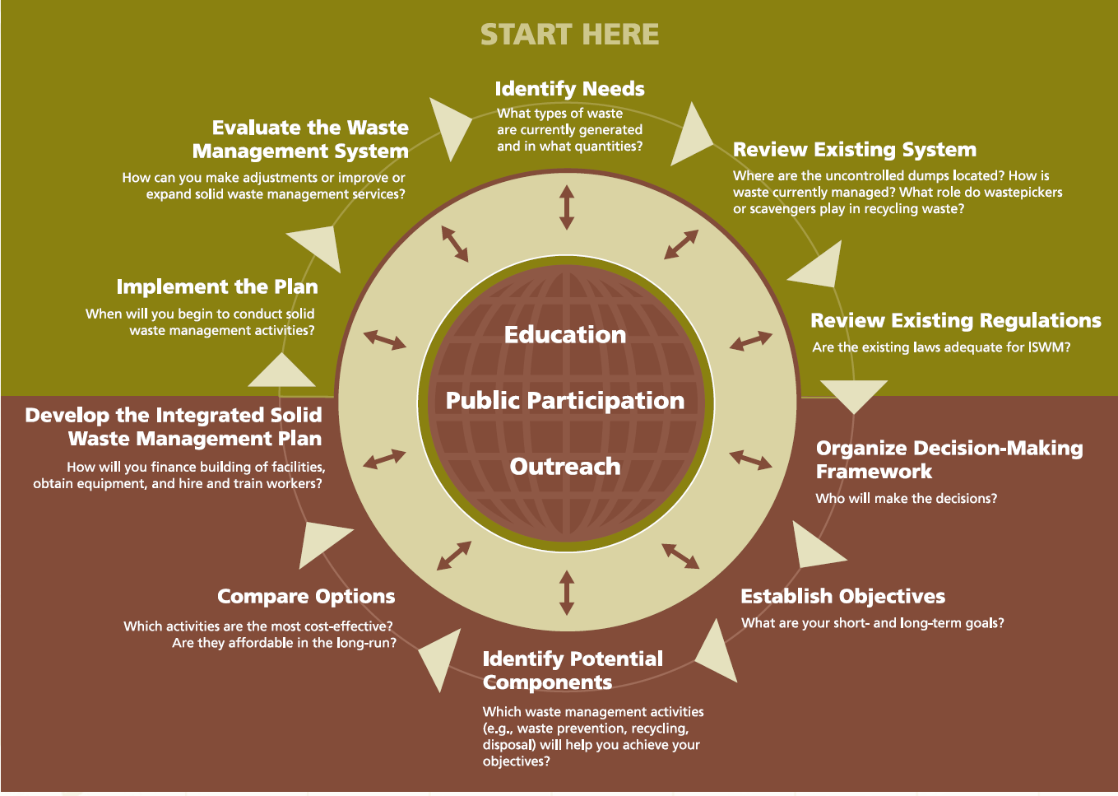
To address the global and local impacts of waste generation and disposal, sustainable waste management systems must be planned, developed, and operated within the framework of local resource availability, social participatory approaches, economics, and environmental concerns. A sustainable solid waste system may support cities to deliver a holistic approach to waste management operations through improved disposal, collection and transportation, better recycling, organics utilization, landfill diversion and alternative disposal. By understanding the benefits and disadvantages of various management technologies, local decision makers can best allocate resources, select processes and vendors, and develop policies and procedures to meet the community’s needs while reducing emissions.

Most of the latest efforts focus on “Zero Waste” and/or “Zero Landfilling” which is certainly expensive for weaker economies, yet a challenge for stronger ones. The NYC Department of Sanitation (DSNY), which is the world’s largest sanitation department, collects more than 10,500 tons of residential and institutional garbage and 1,760 tons of the recyclables each day. While efficiently managing solid waste and clearing litter or snow from 6,300 miles of streets, DSNY is also a leader in environmentalism committing to sending zero waste to landfills by 2030.

Class review schedule

No | Date | Class Review Schedule - Topic (T), learning objectives [L#]
1 | 2021.01.14 | T: Integrated solid waste management (ISWM), sources and quantities [L1, L2]  Synoptic review of previous class material by: N/A
2 | 2021.01.21 | T: Federal, State and City/Local legislation, (i.e., RCRA, CERCLA, TSCA, etc.) [L1]
3 | 2021.01.28 | T: Types and characteristics of waste streams [L1]  Synoptic review of previous class material by: : Emily Gaston
4 | 2021.02.04 | T: Management of RCRA-regulated hazardous and universal wastes, … [L1]  Synoptic review of previous class material by: Christopher Hannigan
5 | 2021.02.11 | T: Collection and transportation of solid waste [L1]  Synoptic review of previous class material by: Junde He
6 | 2021.02.18 | T: Source quantity and toxicity reduction (including reuse) [L5]  Synoptic review of previous class material by: Yunjeong Hong
7 | 2021.02.25 | T: Recycling and markets and products for recycled materials [L1, L2]  Synoptic review of previous class material by: Allison Reser
-- | 2021.03.04 | Spring Break [Monday, March 1-Friday, March 5]
8 | 2021.03.11 | Mid-term exam – Presentation of Case Study assignment
9 | 2021.03.18 | T: Composting [L1, L2]  Synoptic review of previous class material by: Sophia Spangler
10 | 2021.03.25 | T: Incineration: waste-to-energy combustion and emission control [L1, L2]  Synoptic review of previous class material by: Kivia Sugiarto
11 | 2021.04.01 | T: Land disposal: Landfilling [L1, L2]  Synoptic review of previous class material by: Elaine Tu
12 | 2021.04.08 | T: Social and economic concerns, … [L1, L2, L6]  Synoptic review of previous class material by: TBA
13 | 2021.04.15 | T: Innovative approaches to solid waste management [L3, L7]  Synoptic review of previous class material by: TBA
14 | 2021.04.22 | Final exam - Presentation of Research Study assignment

